Khyber Pakhtunkhwa Board of Trade& Testing Board

**DIPLOMA OF INFORMATION TECHNOLOGY**

**FINAL PROJECT**

**For D.I.T - 2nd Semester**

**WEBSITE ON**

**EDUCATION QUOTATIONS**

**Submitted to: Khyber Pakhtunkhwa Board of Trade Testing, Peshawar**

**Submitted by: Syed Anis Sherazi**

**Roll No:49747**

**Semester: 2nd**

**Center: Dream Academy Mansehra**

**Hosted at:** [**http://www.sherazi.tk**](http://www.sherazi.tk)

***http://www.sherazi.cc.vg***

**http://www.sherazi322.blogspot.com**

**HOME PAGE**

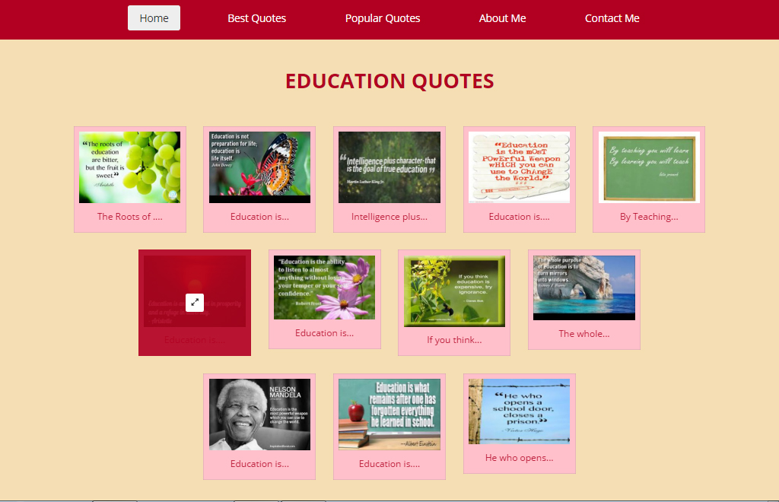

**SECOND PAGE**

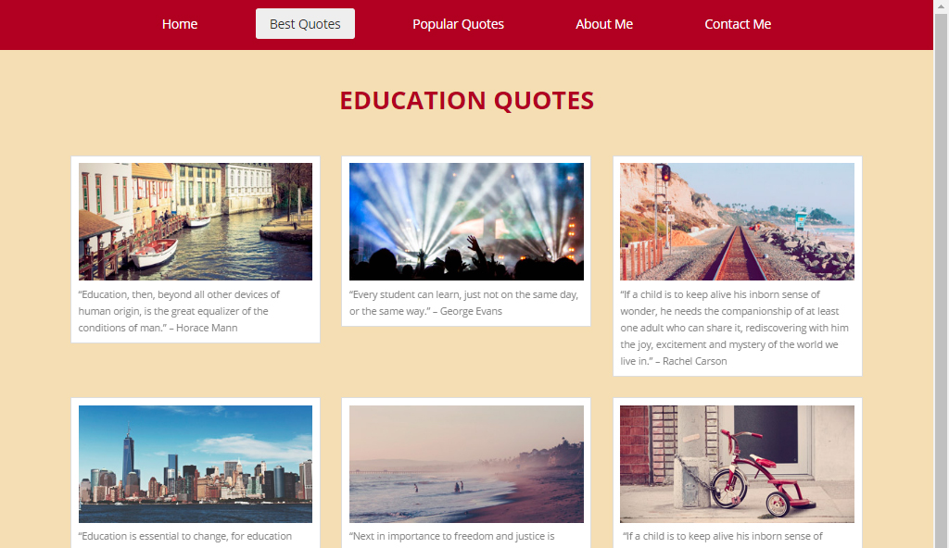

**THIRD PAGE**

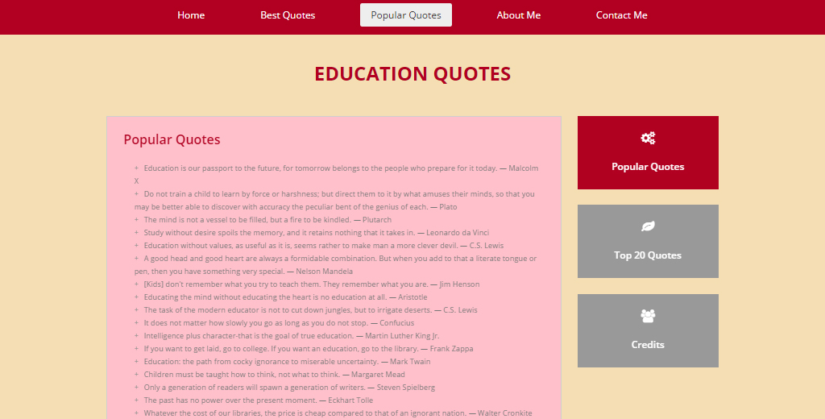

**SOURCE CODE**

<!DOCTYPE html>

<head>

<title>EDUCATIONAL QUOTES</title>

<meta name="keywords" content="">

<meta name="description" content="">

<meta name="viewport" content="width=device-width, initial-scale=1.0">

<meta charset="UTF-8">

<link href="http://fonts.googleapis.com/css?family=Open+Sans:400italic,600italic,700italic,400,600,700,800" rel="stylesheet" type="text/css">

<!—CSS Files Linking -->

<link rel="stylesheet" href="css/bootstrap.min.css">

<link rel="stylesheet" href="css/animate.css">

<link rel="stylesheet" href="css/font-awesome.min.css">

<link rel="stylesheet" href="css/templatemo_misc.css">

<!-- Main CSS -->

<link rel="stylesheet" href="css/templatemo_style.css">

<!-- Favicons -->

<link rel="shortcut icon" href="images/ico/favicon.ico">

</head><body style="">

<div class="site-header">

<div class="main-navigation">

<div class="responsive_menu">

<ul>

<li><a class="show-1 templatemo_home" href="#">Gallery</a></li>

<li><a class="show-2 templatemo_page2" href="#">Products</a></li>

<li><a class="show-3 templatemo_page3" href="#">Services</a></li>

<li><a class="show-4 templatemo_page4" href="#">About Us</a></li>

<li><a class="show-5 templatemo_page5" href="#">Contact Us</a></li>

</ul>

</div>

<div class="container">

<div class="row">

<div class="col-md-12 responsive-menu">

<a href="#" class="menu-toggle-btn">

<i class="fafa-bars"></i></a>

</div>

<!-- /.col-md-12 -->

<div class="col-md-12 main_menu">

<ul>

<li><a class="show-1 templatemo_home active" href="#">Home</a></li>

<li><a class="show-2 templatemo_page2" href="#">Best Quotes</a></li>

<li><a class="show-3 templatemo_page3" href="#">Popular Quotes</a></li>

<li><a class="show-4 templatemo_page4" href="#">About Us</a></li>

<li><a class="show-5 templatemo_page5" href="#">Contact Us</a></li>

</ul>

div><!-- /.col-md-12 -->

</div><!-- /.row -->

</div><!-- /.container --></div><!-- /.main-navigation -->

<div class="container">

<div class="row">

<div class="col-md-12 text-center">

<a href="#" class="templatemo_logo">

<h1>EDUCATION QUOTES </h1>

</a><!-- /.logo -->

</div><!-- /.col-md-12 -->

</div><!-- /.row -->

</div><!-- /.container -->

</div><!-- /.site-header -->

<div id="menu-container">

<div class="content homepage" id="menu-1">

<div class="container-fluid">

<div class="row">

<div class="col-md-2 col-sm-6 col-md-offset-1">

<div class="gallery-item">

<imgsrc="images/gallery/gallery-item1.jpg" alt="image 1">

<div class="overlay" style="display: none; ">

<a href="images/gallery/gallery-item1.jpg" data-rel="lightbox" class="fafa-expand"></a>

</div>

<div class="content-gallery">

<h3>The Roots of ....</h3>

</div>

</div><!-- /.gallery-item -->

</div><!-- /.col-md-2 -->

<div class="col-md-2 col-sm-6">

<div class="gallery-item">

<div class="image">

<div class="overlay" style="display: none; ">

<a href="images/gallery/gallery-item2.jpg" data-rel="lightbox" class="fafa-expand"></a>

</div>

<imgsrc="images/gallery/gallery-item2.jpg" alt="image 2">

</div>

<div class="content-gallery">

<h3>Education is...</h3>

</div>

</div><!-- /.gallery-item -->

</div><!-- /.col-md-2 -->

<div class="col-md-2 col-sm-6">

<div class="gallery-item">

<div class="image">

<div class="overlay" style="display: none; ">

<a href="images/gallery/gallery-item3.jpg" data-rel="lightbox" class="fafa-expand"></a>

</div>

<imgsrc="images/gallery/gallery-item3.jpg" alt="image 3">

</div>

<div class="content-gallery">

<h3>Intelligence plus...</h3>

</div>

</div><!-- /.gallery-item -->

</div><!-- /.col-md-2 -->

<div class="col-md-2 col-sm-6">

<div class="gallery-item">

<div class="image">

<div class="overlay" style="display: none; ">

<a href="images/gallery/gallery-item4.jpg" data-rel="lightbox" class="fafa-expand"></a>

</div>

<imgsrc="images/gallery/gallery-item4.jpg" alt="image 4">

</div>

<div class="content-gallery">

<h3>Education is....</h3>

</div>

</div><!-- /.gallery-item -->

</div><!-- /.col-md-2 -->

<div class="col-md-2 col-sm-6">

<div class="gallery-item">

<div class="image">

<div class="overlay" style="display: none; ">

<a href="images/gallery/gallery-item5.jpg" data-rel="lightbox" class="fafa-expand"></a>

</div>

<imgsrc="images/gallery/gallery-item5.jpg" alt="image 5">

</div>

<div class="content-gallery">

<h3>By Teaching...</h3>

</div>

</div><!-- /.gallery-item -->

</div><!-- /.col-md-2 -->

<div class="col-md-2 col-sm-6 col-md-offset-2">

<div class="gallery-item">

<div class="image">

<div class="overlay" style="display: none; ">

<a href="images/gallery/gallery-item6.jpg" data-rel="lightbox" class="fafa-expand"></a>

</div>

<imgsrc="images/gallery/gallery-item6.jpg" alt="image 6">

</div>

<div class="content-gallery">

<h3>Education is....</h3>

</div>

</div><!-- /.gallery-item -->

</div><!-- /.col-md-2 -->

<div class="col-md-2 col-sm-6">

<div class="gallery-item">

<div class="image">

<div class="overlay" style="display: none; ">

<a href="images/gallery/gallery-item7.jpg" data-rel="lightbox" class="fafa-expand"></a>

</div>

<imgsrc="images/gallery/gallery-item7.jpg" alt="image 7">

</div>

<div class="content-gallery">

<h3>Education is...</h3>

</div>

</div><!-- /.gallery-item -->

</div><!-- /.col-md-2 -->

<div class="col-md-2 col-sm-6">

<div class="gallery-item">

<div class="image">

<div class="overlay" style="display: none; ">f

<a href="images/gallery/gallery-item8.jpg" data-rel="lightbox" class="fafa-expand"></a>

</div>

<imgsrc="images/gallery/gallery-item8.jpg" alt="image 8">

</div>

<div class="content-gallery">

<h3>If you think...</h3>

</div>

</div><!-- /.gallery-item -->

</div><!-- /.col-md-2 -->

<div class="col-md-2 col-sm-6">

<div class="gallery-item">

<div class="image">

<div class="overlay" style="display: none; ">

<a href="images/gallery/gallery-item9.jpg" data-rel="lightbox" class="fafa-expand"></a>

</div>

<imgsrc="images/gallery/gallery-item9.jpg" alt="image 9">

</div>

<div class="content-gallery">

<h3>The whole...</h3>

</div>

</div><!-- /.gallery-item -->

</div><!-- /.col-md-2 -->

<div class="col-md-2 col-sm-6 col-md-offset-3">

<div class="gallery-item">

<div class="image">

<div class="overlay" style="display: none; ">

<a href="images/gallery/gallery-item10.jpg" data-rel="lightbox" class="fafa-expand"></a>

</div>

<imgsrc="images/gallery/gallery-item10.jpg" alt="image 10">

</div>

<div class="content-gallery">

<h3>Education is...</h3>

</div>

</div><!-- /.gallery-item -->

</div><!-- /.col-md-2 -->

<div class="col-md-2 col-sm-6">

<div class="gallery-item">

<div class="image">

<div class="overlay" style="display: none; ">

<a href="images/gallery/gallery-item11.jpg" data-rel="lightbox" class="fafa-expand"></a>

</div>

<imgsrc="images/gallery/gallery-item11.jpg" alt="image 11">

</div>

<div class="content-gallery">

<h3>Education is....</h3>

</div>

</div><!-- /.gallery-item -->

</div><!-- /.col-md-2 -->

<div class="col-md-2 col-sm-6">

<div class="gallery-item">

<div class="image">

<div class="overlay" style="display: none; ">

<a href="images/gallery/gallery-item12.jpg" data-rel="lightbox" class="fafa-expand"></a>

</div>

<imgsrc="images/gallery/gallery-item12.jpg" alt="image 12">

</div>

<div class="content-gallery">

<h3>He who opens...</h3>

</div>

</div><!-- /.gallery-item -->

</div><!-- /.col-md-2 -->

</div><!-- /.row -->

</div><!-- /.slide-item -->

</div><!-- /.homepage -->

<div class="content products" id="menu-2" style="display: none; ">

<div class="container">

<div class="row">

<div class="col-md-4 col-sm-6">

<div class="product-item">

<imgsrc="images/products/product1.jpg" alt="product 1"> “Education, then, beyond all other devices of human origin, is the great equalizer of the conditions of man.” – Horace Mann</div><!-- /.product-item -->

</div><!-- /.col-md-4 -->

<div class="col-md-4 col-sm-6">

<div class="product-item">

<imgsrc="images/products/product2.jpg" alt="product 2"> “Every student can learn, just not on the same day, or the same way.” –&nbsp;George Evans </div><!-- /.product-item -->

</div><!-- /.col-md-4 -->

<div class="col-md-4 col-sm-6">

<div class="product-item">

<imgsrc="images/products/product3.jpg" alt="product 3">“If a child is to keep alive his inborn sense of wonder, he needs the companionship of at least one adult who can share it, rediscovering with him the joy, excitement and mystery of the world we live in.” – Rachel Carson </div><!-- /.product-item -->

</div><!-- /.col-md-4 -->

<div class="col-md-4 col-sm-6">

<div class="product-item">

<imgsrc="images/products/product4.jpg" alt="product 4"> “Education is essential to change, for education creates both new wants and the ability to satisfy them.” – Henry Steele Commager </div><!-- /.product-item -->

</div><!-- /.col-md-4 -->

<div class="col-md-4 col-sm-6">

<div class="product-item">

<imgsrc="images/products/product5.jpg" alt="product 5">“Next in importance to freedom and justice is popular education, without which neither freedom nor justice can be permanently maintained.” – James A Garfield </div><!-- /.product-item -->

</div><!-- /.col-md-4 -->

<div class="col-md-4 col-sm-6">

<div class="product-item">

<imgsrc="images/products/product6.jpg" alt="product 6">&nbsp;“If a child is to keep alive his inborn sense of wonder, he needs the companionship of at least one adult who can share it, rediscovering with him the joy, excitement and mystery of the world we live in.” – Rachel Carson </div><!-- /.product-item -->

</div><!-- /.col-md-4 -->

</div><!-- /.row -->

</div><!-- /.slide-item -->

</div><!-- /.products -->

<div class="content services" id="menu-3">

<div class="container">

<div class="row">

<div class="col-md-9 col-sm-10">

<div class="inner-content">

<div class="toggle-content" id="tab1">

<h2 class="page-title">Popular Quotes</h2>

<ul>

<li>Education is our passport to the future, for tomorrow belongs to the people who prepare for it today.

? Malcolm X</li>

<li>Do not train a child to learn by force or harshness; but direct them to it by what amuses their minds, so that you may be better able to discover with accuracy the peculiar bent of the genius of each.

? Plato</li>

<li>The mind is not a vessel to be filled, but a fire to be kindled.

? Plutarch</li>

<li>Study without desire spoils the memory, and it retains nothing that it takes in.

? Leonardo da Vinci</li>

<li>Education without values, as useful as it is, seems rather to make man a more clever devil.

? C.S. Lewis</li>

<li>A good head and good heart are always a formidable combination. But when you add to that a literate tongue or pen, then you have something very special.

? Nelson Mandela</li>

<li>[Kids] don't remember what you try to teach them. They remember what you are.

? Jim Henson</li>

<li>Educating the mind without educating the heart is no education at all.

? Aristotle</li>

<li>The task of the modern educator is not to cut down jungles, but to irrigate deserts.

? C.S. Lewis</li>

<li>It does not matter how slowly you go as long as you do not stop.

? Confucius</li>

<li>Intelligence plus character-that is the goal of true education.

? Martin Luther King Jr.</li>

<li>If you want to get laid, go to college. If you want an education, go to the library.

? Frank Zappa</li>

<li>Education: the path from cocky ignorance to miserable uncertainty.

? Mark Twain</li>

<li>Children must be taught how to think, not what to think.

? Margaret Mead</li>

<li>Only a generation of readers will spawn a generation of writers.

? Steven Spielberg</li>

<li>The past has no power over the present moment.

? Eckhart Tolle</li>

<li>Whatever the cost of our libraries, the price is cheap compared to that of an ignorant nation.

? Walter Cronkite</li>

<li>Education is the ability to listen to almost anything without losing your temper or your self-confidence.

? Robert Frost</li>

<li>I did then what I knew how to do. Now that I know better, I do better.

? Maya Angelou</li>

<li>The world is a book and those who do not travel read only one page.

? Augustine of Hippo</li>

<li>You educate a man; you educate a man. You educate a woman; you educate a generation.

? Brigham Young</li>

<li>You can never be overdressed or overeducated.

? Oscar Wilde</li>

<li>I have never let my schooling interfere with my education.

? Mark Twain</li>

</ul>

</div><!-- /.toggle-content -->

<div class="toggle-content" id="tab2" style="display: none; ">

<h2 class="page-title">Top 20 Quotes</h2>

<ul>

<li>It is impossible for a man to learn what he thinks he already knows.

Epictetus</li>

<li>Have you ever been at sea in a dense fog, when it seemed as if a tangible white darkness shut you in and the great ship, tense and anxious, groped her way toward the shore with plummet and sounding-line, and you waited with beating heart for something to happen? I was like that ship before my education began, only I was without compass or sounding line, and no way of knowing how near the harbor was. "Light! Give me light!" was the wordless cry of my soul, and the light of love shone on me in that very hour.

Helen Keller</li>

<li>If the only tool you have is a hammer, you tend to see every problem as a nail.

Abraham Maslow</li>

<li>You can teach a student a lesson for a day; but if you can teach him to learn by creating curiosity, he will continue the learning process as long as he lives.

Clay P. Bedford</li>

<li>Aim for success, not perfection. Never give up your right to be wrong, because then you will lose the ability to learn new things and move forward with your life. Remember that fear always lurks behind perfectionism.

David M. Burns</li>

<li>A teacher affects eternity; he can never tell where his influence stops.

Henry B Adams</li>

<li>Keep away from people who try to belittle your ambitions. Small people always do that, but the really great make you feel that you, too, can become great.

Mark Twain</li>

<li>The first problem for all of us, men and women, is not to learn, but to unlearn.

Gloria Steinem</li>

<li>Children have never been very good at listening to their elders, but they have never failed to imitate them.

James Baldwin</li>

<li>Education is a progressive discovery of our own ignorance.

Will Durant</li>

<li>The difference between school and life? In school, you're taught a lesson and then given a test. In life, you're given a test that teaches you a lesson.

Tom Bodett</li>

<li>Tell me and I'll forget; show me and I may remember; involve me and I'll understand.

Chinese proverb</li>

<li>If someone is going down the wrong road, he doesn't need motivation to speed him up. What he needs is education to turn him around.

Jim Rohn</li>

<li>People learn something every day, and a lot of times it's that what they learned the day before was wrong.

Bill Vaughan</li>

<li>Education cost money, but then so does ignorance.

Claus Moser</li>

<li>What sculpture is to a block of marble

education is to the human soul.

Joseph Addison</li>

<li>Education makes a people easy to lead

but difficult to drive: easy to govern, but impossible to enslave.

Peter Brougham</li>

<li>Do not train children to learning by force and harshness, but direct them to it by what amuses their minds, so that you may be better able to discover with accuracy the peculiar bent of the genius of each.

Plato</li>

<li>It is in fact a part of the function of education to help us escape, not from our own time — for we are bound by that — but from the intellectual and emotional limitations of our time.

T.S. Eliot</li>

<li>If people did not do silly things, nothing intelligent would ever get done.

Ludwig Wittgenstein</li>

<li>The beautiful thing about learning is that no one can take it away from you.

B.B. King</li>

</ul></div><!-- /.toggle-content -->

<div class="toggle-content" id="tab3" style="display: none; ">

<h2 class="page-title">Credits </h2>

<p>This website is created using the following software;</p>

<ul>

<li>Dreamweaver CS 5 </li>

<li>Corel Draw x7</li>

<li>CSS - Cascade Style Sheet </li>

<li>Bootstrap Template</li>

</ul>

<p>&nbsp;</p>

</div>

<!-- /.toggle-content -->

</div><!-- /.inner-content -->

</div><!-- /.col-md-9 -->

<div class="col-md-3 col-sm-2">

<div id="icons">

<ul class="tabs">

<li>

<a href="#tab1" class="icon-item active">

<i class="fafa-cogs"></i>

<span>Popular Quotes</span>

</a><!-- /.icon-item -->

</li>

<li>

<a href="#tab2" class="icon-item">

<i class="fafa-leaf"></i>

<span>Top 20 Quotes</span>

</a><!-- /.icon-item -->

</li>

<li>

<a href="#tab3" class="icon-item">

<i class="fafa-users"></i>

<span>Credits</span>

</a><!-- /.icon-item -->

</li>

</ul>

</div><!-- /.icons -->

</div><!-- /.col-md-3 -->

</div><!-- /.row -->

</div><!-- /.container -->

</div><!-- /.services -->

<div class="content about" id="menu-4">

<div class="container">

<div class="row">

<div class="col-md-9 col-sm-10">

<div class="about-us-content">

<div class="toggle-content" id="tab4">

<h2 class="page-title">About me</h2>

<table width="440" border="0">

<tbody><tr>

<td width="105"><strong>Name: </strong></td>

<td width="286">Syed Anis Sherazi</td>

<td width="35">&nbsp;</td>

</tr>

<tr>

<td><strong>F/Name: </strong></td>

<td>Sabir Husain Shah</td>

<td>&nbsp;</td>

</tr>

<tr>

<td><strong>D.O.B: </strong></td>

<td>03.03.1995</td>

<td>&nbsp;</td>

</tr>

<tr>

<td><strong>Roll No:</strong></td>

<td>49747</td>

<td>&nbsp;</td>

</tr>

</tbody></table>

<p>

</p></div><!-- /.toggle-content -->

<div class="toggle-content" id="tab5" style="display: none; "> <h2 class="page-title">D.I.T 1st Semester</h2>

<table width="648" border="0">

<tbody><tr>

<td colspan="3"><div align="center">

<p><strong>DIT 1st SEMESTER MARKS</strong></p>

</div></td>

</tr>

<tr>

<td width="310"><strong>SUBJECT</strong></td>

<td width="162"><strong>MARKS OBTAINED </strong></td>

<td width="162"><strong>TOTAL MARKS</strong></td>

</tr>

<tr>

<td>Information &amp; Communication Technology</td>

<td>122</td>

<td> 150 </td>

</tr>

<tr>

<td>Office Automation (Word/ Excel/PowerPoint)</td>

<td>111</td>

<td> 150</td>

</tr>

<tr>

<td>Computer Network</td>

<td>127</td>

<td> 150</td>

</tr>

<tr>

<td>Computer Programming C/C++</td>

<td>81</td>

<td> 100</td>

</tr>

</tbody></table>

<p>&nbsp;</p>

</div><!-- /.toggle-content -->

</div><!-- /.inner-content -->

</div><!-- /.col-md-9 -->

<div class="col-md-3 col-sm-2">

<div id="icons-about">

<ul class="tabs">

<li>

<a href="#tab4" class="icon-item active">

<i class="fafa-umbrella"></i>

<span>About Me</span>

</a><!-- /.icon-item -->

</li>

<li>

<a href="#tab5" class="icon-item">

<i class="fafa-camera"></i>

<span>D.I.T 1st SEMESTER</span>

</a><!-- /.icon-item -->

</li>

</ul>

</div><!-- /.icons -->

</div><!-- /.col-md-3 -->

</div><!-- /.row -->

</div><!-- /.container -->

</div><!-- /.services -->

<div class="content contact" id="menu-5">

<div class="container">

<div class="row">

<div class="col-md-12">

<div class="widget-content">

<div class="page-title">

<p>Contact Us</p>

<p>&nbsp;</p>

</div>

<table width="440" border="0">

<tbody><tr>

<td><strong>Address:</strong></td>

<td colspan="3">Mansehra Punjab chowk chakriali battian sherazi house </td>

<td>&nbsp;</td>

<tr>

<td width="67"><strong>Cell:</strong></td>

<td colspan="3">0346-5631960</td>

<td width="35">&nbsp;</td>

</tr>

<tr>

<td><strong>E-Mail:</strong></td>

<td colspan="3"><a href="#">anissherazi960@gmail.com</a></td>

<td>&nbsp;</td>

</tr>

<tr>

<td><strong>Social: </strong></td>

<td width="106"><strong>Facebook</strong></td>

</tr>

<tr>

<td>&nbsp;</td>

<td>facebook\anis.sherazi</td>

</tr>

</tbody></table>

</div>

<!-- /#menu-container -->

<div id="templatemo_footer">

<div class="container">

<div class="row">

<div class="col-md-12 text-center">

<p>Copyright © 2015 Designed By[ Syed Anis Sherazi] student of dit TTB</p>

</div><!-- /.col-md-12 -->

</div><!-- /.row -->

</div><!-- /.container -->

</div><!-- /.templatemo_footer -->

<!-- Scripts -->

<scriptsrc="js/jquery-1.10.2.min.js"></script>

<scriptsrc="js/jquery-migrate-1.2.1.min.js"></script>

<scriptsrc="js/modernizr.js"></script>

<scriptsrc="js/bootstrap.js"></script>

<scriptsrc="js/tabs.js"></script>

<scriptsrc="js/jquery.lightbox.js"></script>

<scriptsrc="js/templatemo_custom.js"></script>

<!--

-->

<!-- -->

</div></div></div></div></div><div id="lightbox" style="display:none;"><a href="#" class="lightbox-close lightbox-button"></a><div class="lightbox-nav"><a href="#" class="lightbox-previous lightbox-button"></a><a href="#" class="lightbox-next lightbox-button"></a></div><div href="#" class="lightbox-caption"><p></p></div></div></body></html>